**Q1 . The main function here, had two arguments (int argc, char *argv[]), explain their use?**

**Ans.**  Main function always has two arguments by default(or requires two arguments in C), first is the number/ count of arguments and second is argument vector which contains the number of arguments the user gives in the terminal.

For instance in the code I can run it like :

```

./cpu<filename> “first argument” “second argument”

```

And therefore the argc will be 2 and argument vector will contain “first argument” “second argument”.

**Q2: How do we increase the delay in printing strings?**

**Ans:** We can increase the delay by sleep function, or in my case as it was not working on mac so I used a for loop running 1000 * sleep_seconds times to cause a delay after printing a string.

**Q3: What is a shell, and which shell are you in?**

**Ans :** A shell is a program that provides us interface to interact with the Operating system like bash.

To check in which shell we are , we run

```

**echo $SHELL**

**```**

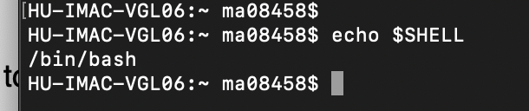

**Q4: What is a “Home Directory,” and what is your Home Directory?**

**Ans:**  The default directory in which the files are typically saved and is accessed when opening a new terminal , and every command more or less of the terminal works in this directory, to check the home directory we run

```

echo $HOME

```

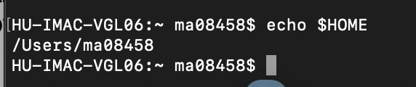

**Q5: What’s a Working Directory and which directory are you in?**

**Ans:**  The current directory we are working in (for instance we are running some commands in a specific folder using BASH ) is the working directory

We can check it via

```

pwd

```

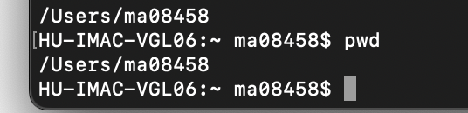

**Q6: Differentiate between an ‘Absolute Path’ and a ‘Relative Path’?**

**Ans:**  The absolute path is the path from the root directory while relative path is the path relative or the path starting from and including its parent folder.

So for example a relative path of a file named “somefile.py” in folder “a folder” will be referred as :

```

**a folder/somefile.py**

```

However for the same file the absolute path will be :

```

**/Users/ma08458/Desktop/lab_01/a file/somefile.py**

**```**

**Q7: What’s the largest file inside the directory “/usr/bin”?**

**Ans:**  We can easily find the largest file using the command :

```

ls -1S /usr/bin/ | head -n -2

```

(-1 lists down directories on separate lines)

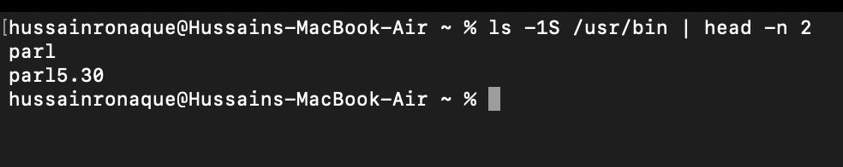

**Parl** would be biggest in size

**Q8: What’s the most recently created file inside the directory /usr/bin?**

**Ans:**  All files are created on same date when I was checking files in macOS whereas, we can check the most recently added file by running the following command :

```

ls -1t /usr/bin/ | head -n -2

```

Note: here 2 means that it will get the top two lines , of which the 2nd line is the most recent file. Moreover this command displays the file in descending order with respect to time.

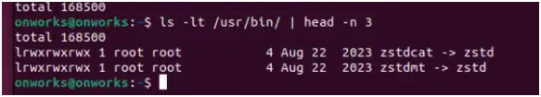

**Q9: List all the hidden files and directories in your home directory.**

Using the ls –a command we can see the hidden directories. The hidden files are the ones that start with `.`

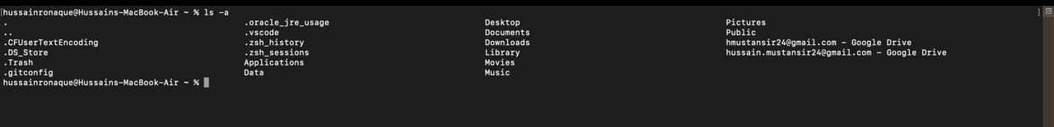

**Q10: What does the command ‘file’ do?**

**Ans:** The command FILE examines the file content to check the file type, (note it does not check the extension but the content inside)

If I run

```

file /bin/ls

```

The output is :

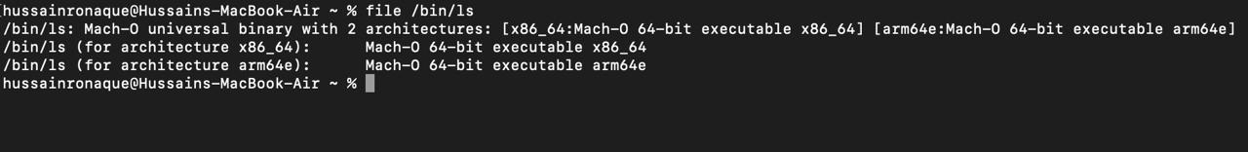

This indicates that file in bin / ls is and executable file type

**Q11: Search for the “-h” option of “ls.” What do they do? Use them.**

**Ans:** -h displays the file sizes in a form that is understandable by us humans, to find the command I ran man

```

ls –help

```

And then found :

To run the following command :

```

ls -1h ~

```

Here the command is used with -1 and h where h is command to make file sizes in human understandable form where as -1 is for listing files on separate lines

**Q12: Make the directory “mine/subdir/subsubdir” using one command only.**

**Ans:** We can make a directory / folder using mkdir command as follows :

```

mkdir -p ~/mine/subdir/subsubdir

```

Here -p is for parent folder which ensure that the parent folder, if not exists is also created.



Output is :

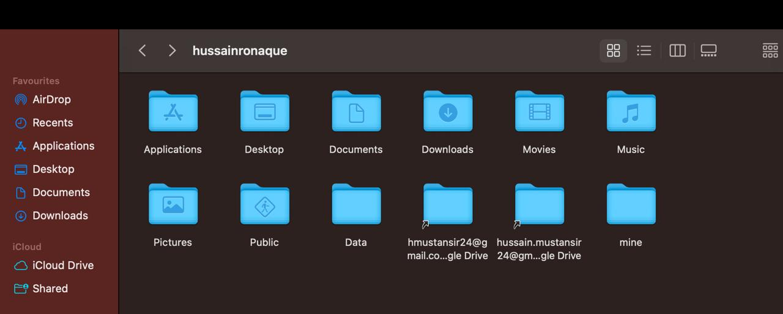



**Q13: While staying in your home directory, create an empty file dummy.txt in mine/subdir/subsubdir.**

**Ans:**  We can make an empty directory using touch command as follows :

```

touch ~/mine/subdir/subsubdir/dummy.txt

```

This will create an empty file if it does not exists with name dummy.txt :

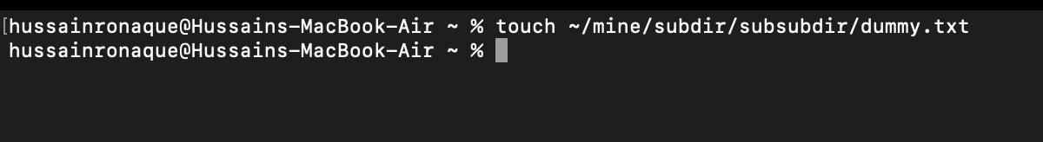

(note : mkdir creates directories, while touch creates empty files or updates the timestamps of existing files )

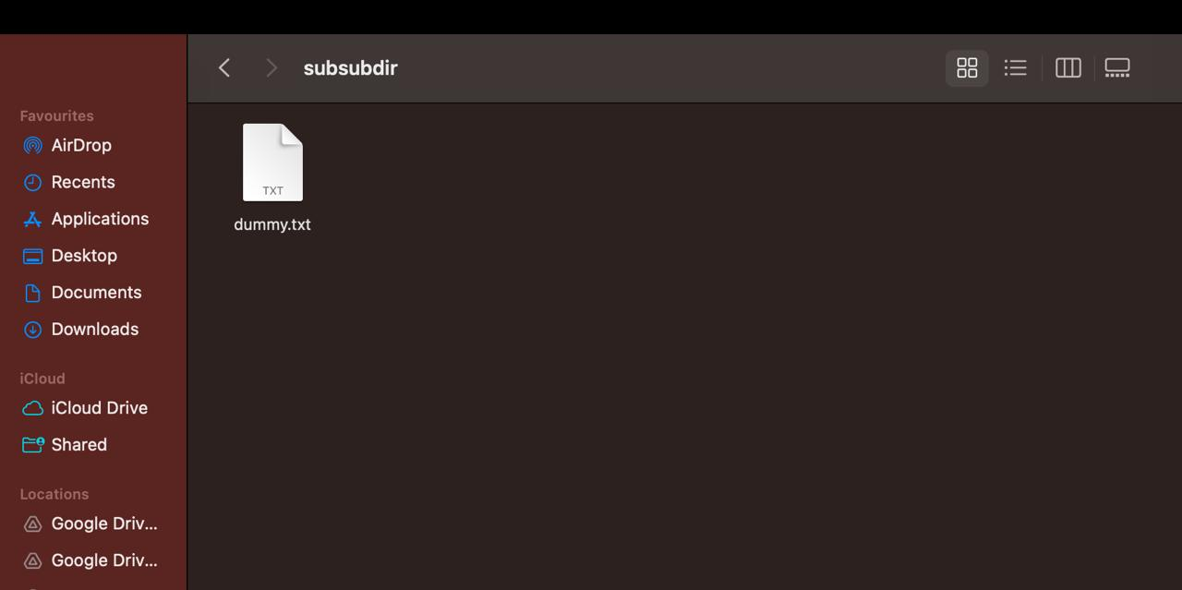

**Q14: While staying in your home directory, copy the files zip, zipgrep, zipinfo from /usr/bin to mine/subdir/subsubdir**

**Ans :** To copy the files we can use the command cp as follows :

```

cp /usr/bin/zip /usr/bin/zipgrep /usr/bin/zipinfo ~/mine/subdir/subsubdir/

```

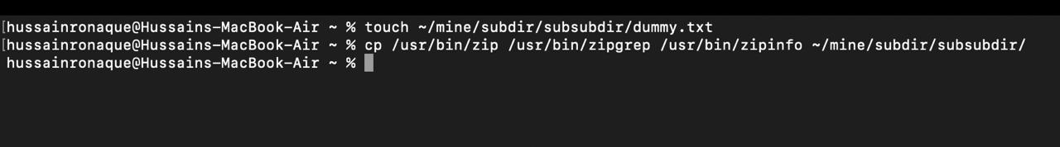

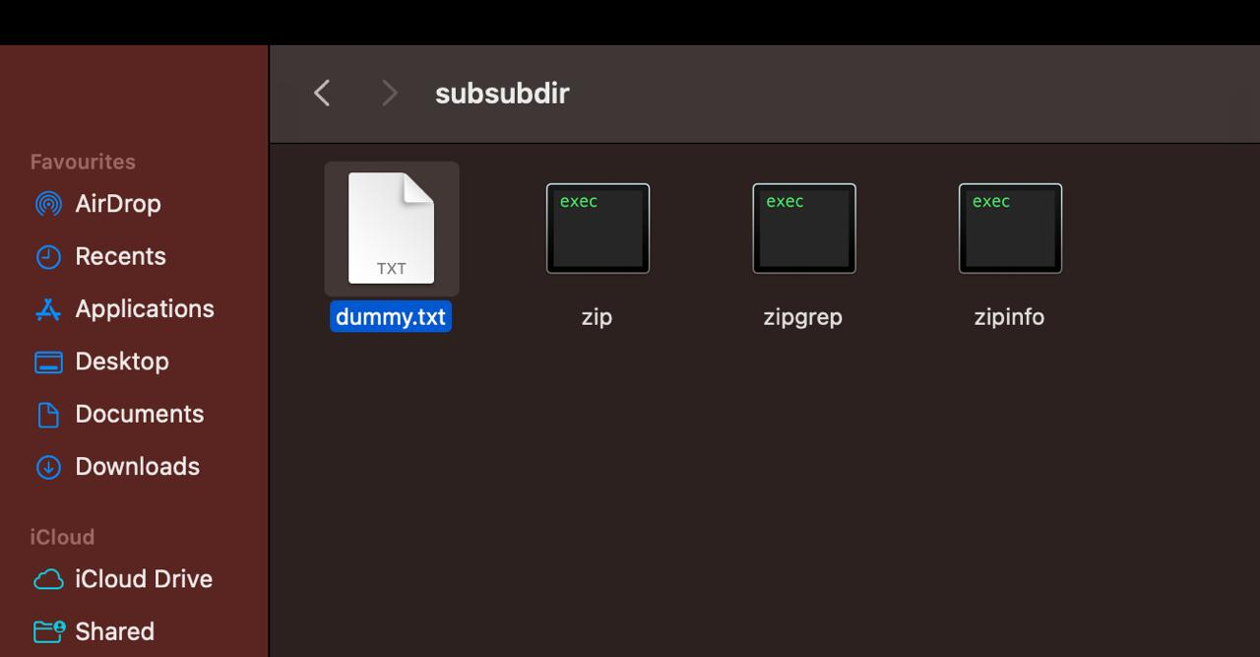

**Q15: Move all files from mine/subdir/subsubdir to mine/subdir/**

**Ans :** We can move the files from one folder to other using mv command as follows :

```

mv ~/mine/subdir/subsubdir/* ~/mine/subdir/

```

(here * in the end of source path indicates to copy the files of all types)

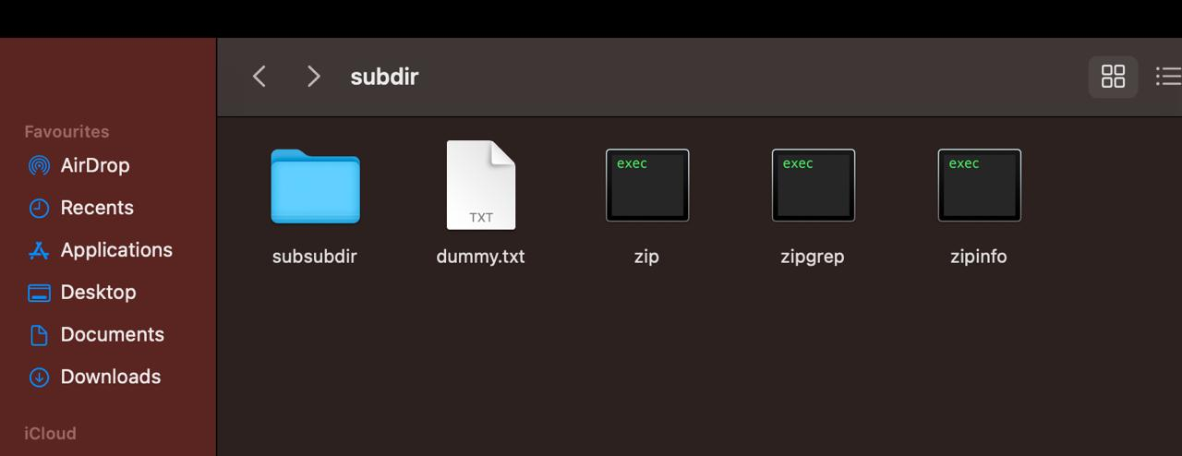

**Q16: List all the files in /etc whose second letter is c.**

**Ans:** We can use ls command with a filter to list down all the files with second letter c

```

ls /etc/?c*

```

So question mark means any one character before c and anything after c making c at the 2nd position.

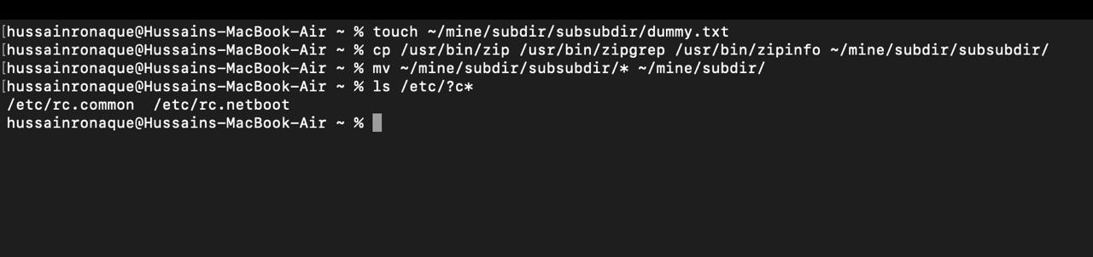

**Q17: Copy all of them to mine/subdir. Then delete all files that contain a digit.**

Ans: We can do this via series of commands :

```

cp /etc/?c* ~/mine/subdir/

```

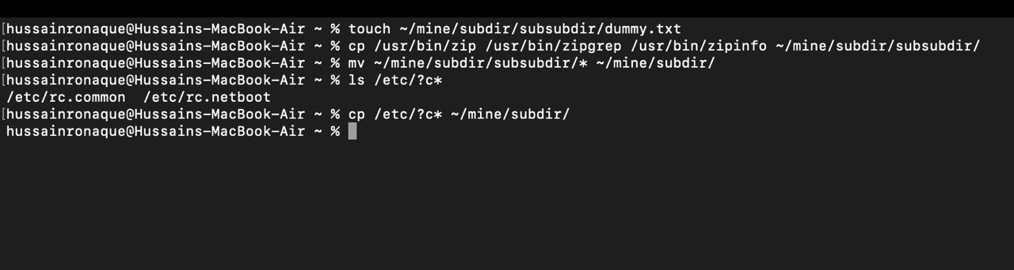

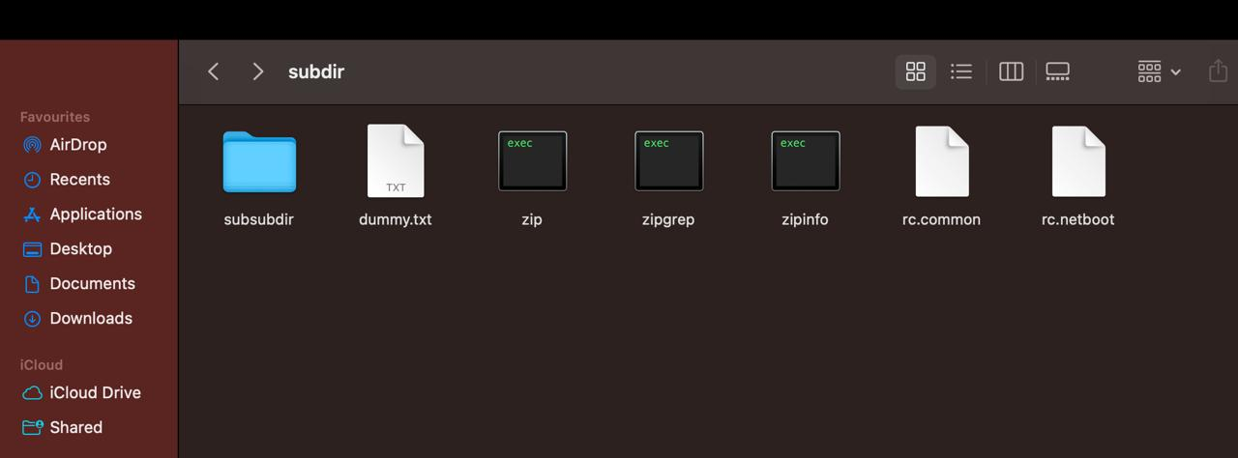

Then to remove the files we run :

```

rm ~/mine/subdir/*[0-9]*

```

**Q18: Delete the mine/subdir/ directory**

We can again use rm command to remove the files /directory

```

rm -r /mine/subdir/

```

The -r ensures all directories alongwith their contents are deleted.

